UiTM Holdings and its subsidiaries have yet to fulfil their mandate: PAC
By Nor Ain Mohamed Radhi, Qistina Sallehuddin - March 18, 2024 @ 11:17am
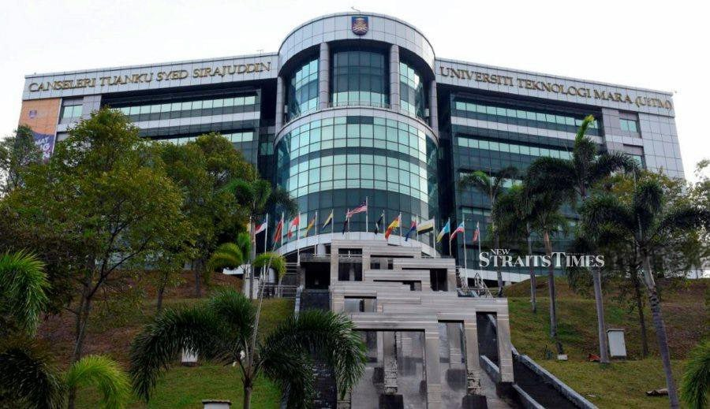UiTM Holdings have yet to fulfil their mandate of generating wealth for UiTM. - NSTP file pic
KUALA LUMPUR: UiTM Holdings and its subsidiaries have yet to fulfil their mandate of generating wealth for UiTM, establishing investment opportunities, and improving the strategic position of the company's main business.
This was among the conclusions made by the Public Accounts Committee (PAC) following its proceedings into UiTM Holdings, following the 2022 Auditor-General's Report.
PAC chairman Datuk Mas Ermieyati Samsudin in a statement today said other conclusions included UiTM's failure to obtain the approval of the Finance Ministry was not in line with Universiti Teknologi Mara Act 1976, resulting in the acquisition of UiTM Private Education Sdn Bhd (UPESB) and UiTM Technoventure Sdn Bhd contrary to the act.
"Capital injection totalling RM259.98 million by UiTM from the year 2007 to 2018 without the approval of the Finance Ministry for shareholding purposes in UiTM Holdings was inconsistent with requirements of the act.
"The solar project by UiTM Holdings is beneficial to the operation of UiTM. However, the change in category of land use at Solar Park I in Gambang, Pahang has yet to be be completed.
"Failure to conclude a new tenancy agreement between UiTM and UiTM Private Healthcare Sdn Bhd (UPHSB) has resulted in a rental arrears of 15 months, causing the UiTM Specialist Health Centre hospital building to be improperly maintained," she said.
She said the proceedings on UiTM Holdings was held on Dec 6 last year, with three individuals called up.
They were the Higher Education Ministry deputy secretary (policy) Datuk Dr Megat Sany Megat Ahmad Supian, UiTM vice-chancellor Prof Datuk Dr Shahrin Sahib and UiTM Holdings acting chief executive officer Farisan Mokhtar.
Mas Ermieyati said to address these matters, there are five recommendations by the PAC for the Higher Education Ministry and UiTM to implement.
"First, UiTM needs to be more effective in regulating UiTM Holdings and its subsidiaries to generate profits and be able to pay dividends in line with the establishment's goals.
"Second, UiTM must ensure compliance with the authority in making investments, loans, and the establishment of subsidiary companies by the provisions of the act.
"Third, the ministry and UiTM must ensure that corrective actions are taken on the issue of capital injections totalling RM259.98 million to align with the act.
"Four, UiTM Holdings must immediately resolve the issue of category of land use at Solar Park I in Gambang.
"Lastly, UiTM Holdings needs to present a comprehensive plan of direction investment and business including dealing with arrears issues against the tenancy of the building for 15 months and maintenance issues of the UiTM Specialist Health Centre hospital building."

