Media Prima's earnings soar 73pct quarter-on-quarter in Q1
By Business Times - November 29, 2023 @ 1:34pm
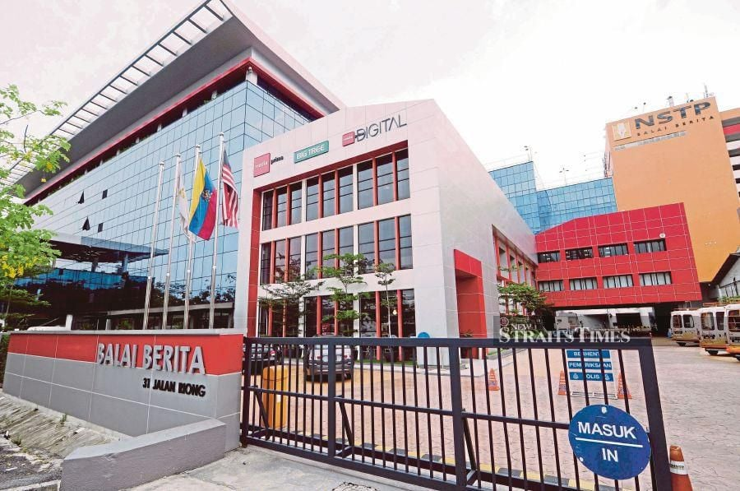Balai Berita Jalan Riong, Kuala Lumpur. NSTP/Asyraf Hamzah
PreviousNext
KUALA LUMPUR: Media Prima Bhd, Malaysia's leading and largest integrated media group, posted a higher net profit quarter-on-quarter in the first quarter (Q1) ended Sept 30 2023.
The group's net profit stood at RM13.9 million, a surge of 73 per cent against the immediate preceding quarter on the back of higher other operating income.
Media Prima said despite facing challenging industry conditions and economic headwinds, it achieved a revenue of RM213.9 million in Q1.
'Advertising revenue remained steady, reaching RM174.7 million for 1QFY24, which is on par with the immediate preceding quarter ended June 30 2023," it said today.
Media Prima said its strong brands, extensive reach and innovative content continue to resonate with audiences and advertisers
During the period under review, the group's publishing business, represented by The New Straits Times Press, recorded a boost in advertising and printing revenue, leading to an 11 per cent increase in total segment revenue in 1QFY24 against the immediate preceding quarter.
Media Prima OMNiA and REV Media Group reported slight increases in revenue compared to the immediate preceding quarter.
The group's Out-of-Home business revenue was on par compared to the immediate preceding quarter while broadcasting recorded a slight revenue reduction due to lower non-advertising revenue.
Media Prima group chairman Datuk Seri (Dr) Syed Hussian Aljunid said the past quarter had been a trying period for the media industry.
"Nonetheless, we remained resilient and posted encouraging results, which is testament to the group's robust business plan and commitment to driving sustainable growth.
"Looking ahead, we expect ongoing economic uncertainties to affect advertising expenditure and consumer sentiment. We remain determined to weather these challenges while delivering value to our shareholders."
The group, he added, will continue to focus on operational efficiency and leverage its core strengths.
Group managing director Rafiq Razali said it is aware of the tougher market conditions and the need to adapt to changing consumer preferences and technological advancements.
"Our three-year business plan, built on content boost, inventory premiumisation, and exploration of new revenue streams, underscores our commitment to drive growth and capitalise on our technological capabilities, data-driven insights, and talented team.
"We will continue to defend our leadership positions, while investing more in growing media platforms namely the digital and our out-of-home segments."
He added that to effectively cater to the evolving needs of the market, Media Prima is strategically investing in the potential of its streaming platform, Tonton, and commerce business, WowShop, to ensure we remain aligned with current trends.
One of the initiatives under Media Prima's three-year business plan is to capitalise from the increasing demand for video streaming services via Tonton.
The group said the platform has undergone a transformation, unveiling a fresh new look and enhanced services across web, mobile, and smart televisions.
"One of the prominent updates introduced is TontonUp, a subscription service that offers exclusive Tonton Originals and simultaneous release titles.
"Since the revamp, Tonton has recorded a 27 per cent growth in registered users and an increase of 46 per cent in live television viewership in 1QFY24 against the immediate preceding quarter. This growth can be attributed to the platform's robust content distribution strategy."
Tonton had earlier launched Smart TV apps which today accounts for 15 per cent of the platform's viewership.
On the humanitarian front, the group has reactivated its Tabung Kemanusiaan Palestin Media Prima in response to the recent humanitarian crisis in Palestine.
"The group is dedicating a significant portion of its media assets to raise donations for humanitarian assistance activities to support the affected communities in the conflict zone.
"Funds collected will be channelled to reputable non-governmental organisations, which will be responsible for providing emergency assistance to the communities affected by the crisis. The assistance will include vital resources such as medical supplies and services, food supplies, and other basic necessities," it added.

