FACULTY OF ELECTRICAL & ELECTRONICS ENGINEERING

EXAMINER ANSWER SCRIPT
TEST 2: SEM 1 YEAR: 2017 / 2018

Subject: ALTERNATIVE ENERGY First Examiner: MOHD SHAWAL JADIN
Subject Code: BEE 4163 Second Examiner: DR. AHMAD SYAHIMAN MOHD SHAH

 |  | Marks
(a) | The maximum open circuit voltage:  $$V_{max⁡_oc}=V_{oc_STC}+\left(γ_{Voc}×\left(T_{cell_eff_min}-T_{STC}\right)\right)$$  $$= 43.1 +\left([ -148mV × \left( 20 -25\right)]\right)$$  $$= 43.84 V$$  maximum peak power voltage:  $$V_{max⁡_mp}=V_{mp_STC}+\left(γ_{Vmp}×\left(T_{cell_eff_min}-T_{STC}\right)\right)$$  $$= 34 +\left( -152 mV ×\left( 20-25\right)\right)$$  $$= 34.76 V$$  minimum peak power voltage of the module:  $$V_{min⁡_mp}=V_{mp_STC}+\left(γ_{Vmp}×\left(T_{cell_eff_max}-T_{STC}\right)\right)$$  $$= 34 +\left(-152mV × \left( 75-25\right)\right)$$  $$= 26.4 V$$  The maximum number of modules per string such that the maximum string voltage shall not damage the inverter:  By considering 5% safety margin, the voltage window for the inverter:  $$V_{max⁡_allow}=530×0.95=503.5 V$$  So, this will allow a maximum number of modules per string:  $$\frac{503.5}{43.84}=11.4849.. (round down to 11 modules)$$  By considering 5% safety margin, the voltage window for the inverter:  $$V_{max⁡_window_allow}=400×0.95=380 V$$  So, the maximum number of modules per string such that the maximum string operating voltage shall not turn off the inverter.:  $$\frac{380}{34.76}=10.9321.. (round down to 10 modules)$$  The minimum number of modules per string:  By considering 10% safety margin, the voltage window for the inverter:  $$V_{min⁡_window_allow}=150×1.1=165 V$$  So the minimum number in a string:  $$\frac{165}{26.4 ×0.95 }=6.5789… (round up to 7 modules)$$  The estimate total array power at stc and total number of modules that matches with the inverter.  Approximate total array power $=\frac{4600}{0.75}=6133.3 W_{p} and \frac{4600}{0.80}=5750 W_{p}$  Aproximate total number of modules:  $$=\frac{6133.3}{160}=38.3331.. (round down to 38 modules)$$  and also  $=\frac{5750}{160}=35.9375 (round up to 36 modules)$.  To determine the maximum number of parallel strings:  $$N_{parallel_string}=\frac{I_{max⁡_dc_inv}}{f_{safety}×I_{sc_string}}$$  $$N_{parallel_string}=\frac{35.84}{1.25×5.2}=5.5138… ≈5 (round down)$$  Parallel Series Total Ratio  4 10 40 0.71875  4 9 36 0.79861111  5 8 40 0.71875  5 7 35 0.82142857  Target derating factor to inverter size k is 0.75 and 0.80. Therefore, the optimum configuration is either 4 X 9. | 1  0.5  1  0.5  1  0.5  0.5  1  0.5  1  0.5  1  0.5  0.5  0.5  0.5  1  0.5  0.5
(b) | First, calculate the length of string cable, Cable A;  L_{DC_cable_string} = (9 x 0.814) + L = 7.326 + 5 = 12.326 m  Thus, string cable, $${ A}_{DC_{cable_string}}=\frac{2×L_{DC_{cable_string}}×I_{DC}×ρ}{LOSS×V_{mp_string}}=\frac{2×12.326×4.71×0.017857}{0.02×\left(34×9\right)}$$  $$=0.3388 {mm}^{2}$$  Based on MS1837:2010 standard, 2.5 mm² will be selected.  Next, array cable, $${ A}_{DC_{cable_array}}=\frac{2×L_{DC_{cable_array}}×I_{DC}×ρ}{LOSS×V_{mp_array}}=\frac{2×(3×5)×(4×4.71)×0.017857}{0.03×\left(34×9\right)}$$  $$=1.0994 {mm}^{2}$$  Based on MS1837:2010 standard, 2.5 mm² will be selected. | 1  1  1  0.5  0.5  1  1  0.5  0.5

 |  | Marks
(a) | Frequently-used charge controllers:  - Pule-Width Modulation (PWM) charge controller  - Maximum Power Point Tracking (MPPT) charge controller  Function - It prevents the batteries from being over-charged or over-discharged. | 1  1  1
(b) | $${ E}_{module}=I_{mp}×PSH×SV$$  $$=4.95×4.2×12$$  $$=249.48 Wh$$ | 1  1  1
(c) | - Panel  $${ N}_{min⁡_panel}=\frac{E_{req_daily}}{E_{mod}×η_{charge}}=\frac{3130}{249.48×0.85} =14.76 \left(round up tp 15 modules\right)$$  - Battery  $\frac{Daily requirement of appliances\left(\frac{Wh}{day}\right)×Period of storage required (days)}{12 V} = Total usable capacity needed (Ah at 12V)$  $$\frac{3130 ×4}{12V}$$  $$= 1043.33 Ah at 12V$$  $\frac{Total usable capacity needed \left(Ah at 12V\right)×100\%}{Full capacity specified for one 12V battery\left(Ah\right)×Maximum depth of cycles(\%)}=Minimum number of 12V batteries needed$  = $\frac{1043.33 ×100}{200 ×70}$  $$=7.4523≈8 batteries (round up)$$  Since, 24 V system is selected,  thus, the configuration for battery is 2 series and 4 parallel. | 1  1  0.5  1  1  1  0.5  1
(d) | 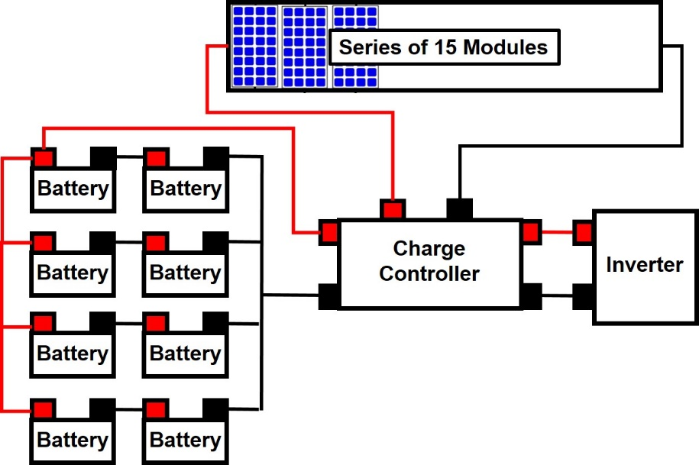 | 1  1  1  1
(e) | - V_{mp} of the string = 4 x 35.4V = 141.6 V  From datasheet, I_{mp} is 4.95 A.  $$V_{drop_DC}=\frac{2×L_{DC_cable}×I_{DC}×ρ}{A_{DC_cable}}$$  $$=\frac{2×35×4.95×0.017857}{2.5}=2.475 V$$  $$V_{drop}\left(\%\right)=\frac{V_{drop_{DC}}}{V_{mp_{string}}}×100=\frac{2.475}{141.6}×100=1.748\%$$ | 1  1  1

